CSIS 100 – Lab 6: UML Diagrams
Background:

“The Unified Modeling Language, or UML, as it is popularly known by its TLA (three-letter acronym!), is the language that can be used to model systems and make them readable. This essentially means that UML provides the ability to capture the characteristics of a system by using notations. UML provides a wide array of simple, easy to understand notations for documenting systems based on the object-oriented design principles. These notations are called the nine diagrams of UML.”
(http://www.developer.com/design/article.php/1553851/UML-Overview.htm)

In this exercise, you will be developing the first of the UML diagrams, known as a Use-Case diagram. Before beginning this lab, be sure to read the articles and watch the videos that are in your Reading & Study folder.

In this lab, you are a Systems Analyst working for Liberty University. It is your responsibility to produce a Use Case diagram (complete with Use Case descriptions for each Use Case) for a system that will model an existing system. The system that you choose to model is your decision. Some examples are the systems that you use to apply for admission to the university, the system you use to sign up for classes, the system you use to order textbooks, or another system of which you are familiar.

To construct your Use Case diagram, you will use a web-based modeling tool that is found at www.draw.io. The instructions to use this tool are as follows:

- Open a web browser and navigate to www.draw.io. You will immediately see a screen like the one below that asks you where you want to save your files. Select “Device” from this screen.
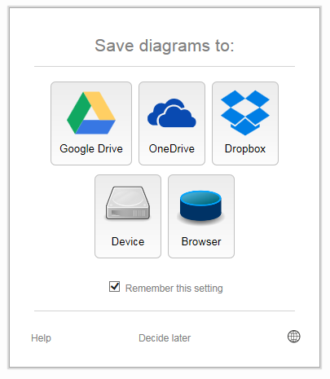
- The next screen prompts you to either Create a new diagram or Open an existing diagram. Click “Create new diagram”.
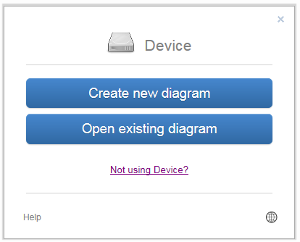

- The next screen prompts you to give your diagram a name and to select a template for your diagram.
  - Name your file using the convention [Your First and Last Name without spaces] followed by “UseCaseDiagram”.
  - Click “Create” to open a Blank Diagram.
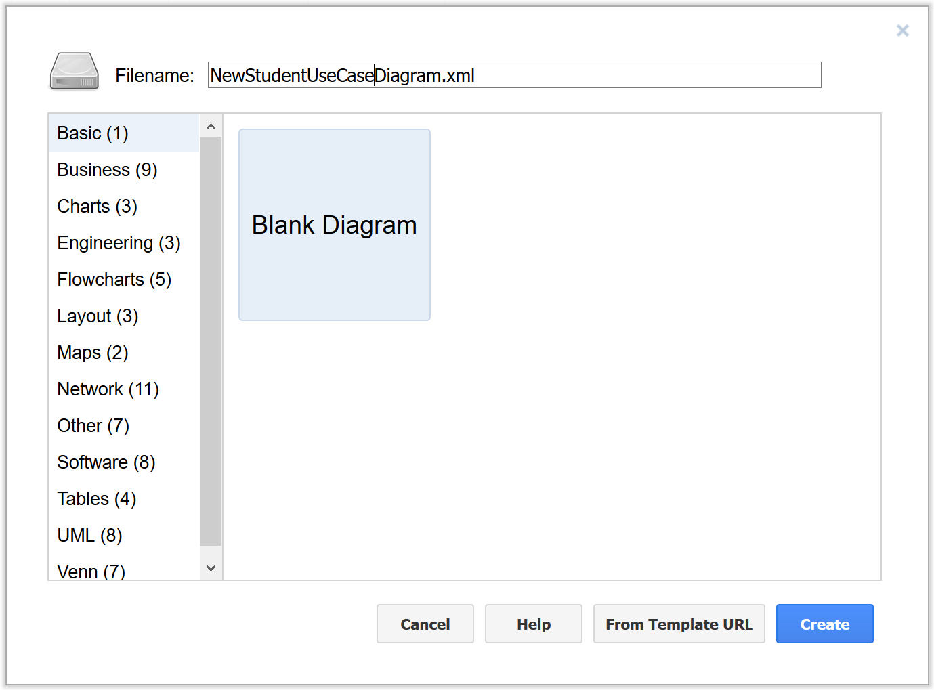

- The next screen that opens is your work area. Click on the UML menu to open UML Standard symbol template.

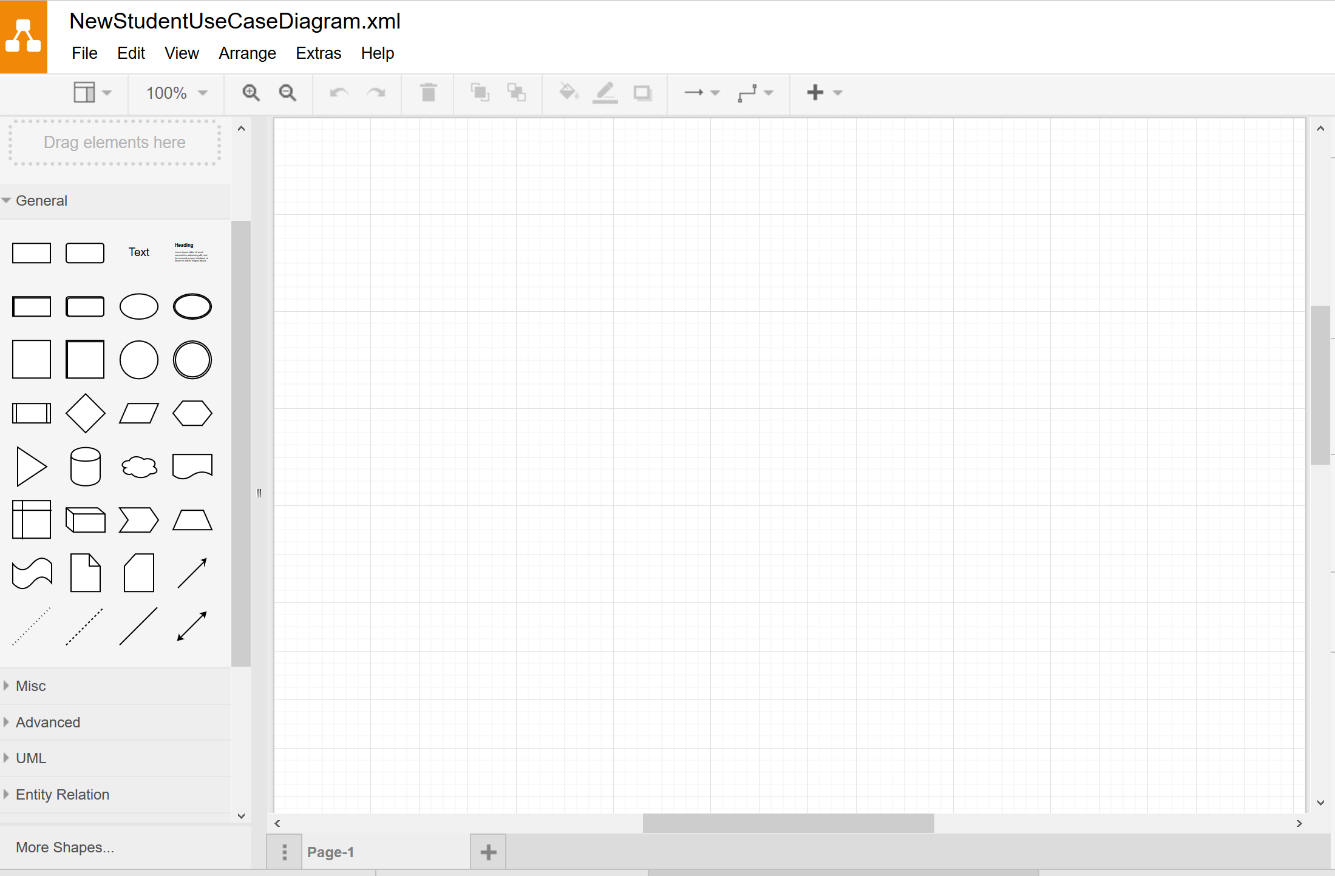

Drag in and drop as many Use Case and Actor symbols as needed for your process. Then build your model based on your three-paragraph Use Case Description.

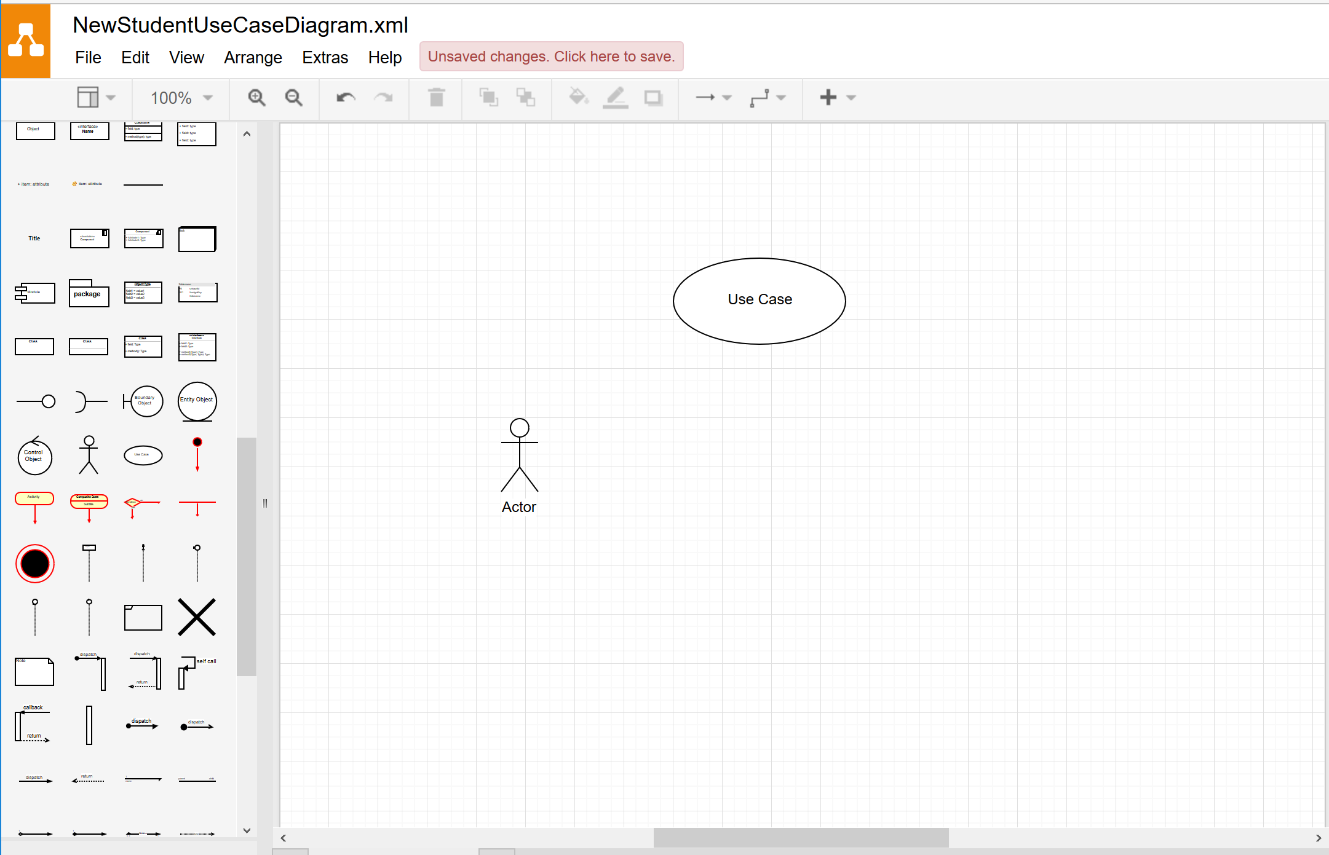

Tasks:
- In a three paragraph summary, describe the system you are modelling. Save this summary in a Word document entitled [Your first name + your last name] + “_Lab 6”.
- Create a Use-Case diagram with a minimum of 3 actors and 5 use cases.
- Include 1 “extends” relationship in your model.
- In the same Word document as your system summary, create use case descriptions for each of the use cases (5 minimun) you identified.

The format of your use case descriptions should be as follows:
Use Case Name:
Participating Actors:
Flow of Events:
Alternative Flows:
Entry Conditions:
Exit Conditions:

[For a discussion and example of use case descriptions, be sure to view the articles and videos in your Reading & Study folder.]

Deliverables:
Upload your diagram (saved as an xml file) and your Word document containing your summary and use case descriptions to the assignment link in Blackboard by the date specified in your course schedule.

